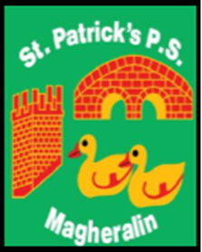

ST. PATRICK’S PRIMARY SCHOOL
12 Ballymacbredan Road, Magheralin, Craigavon. BT67 OQU
Tel no – 028 3834 1400 Fax no – 028 3834 7376
Email: info@stpatricks.magheralin.ni.sch.uk
Principal: Mrs. M. McGrath. BA(QTS), PQHSH, DipPD.
‘Together we learn, together we grow, developing our future, wherever we go!’

10th May 2022

Dear Parents

School Dinner payments

As we approach the end of the school year, we respectfully ask that all dinners are booked and paid for on Eduspot in advance.

If you need to cancel a planned dinner for any reason, please email the school office before 9am on the day the dinner has been booked otherwise it will be ordered and you will be charged.

Our accounts must reconcile with EA School Meals Service.

We thank you in advance for your understanding.

Yours faithfully

School Office

