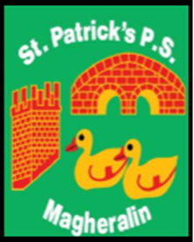

ST. PATRICK’S PRIMARY SCHOOL
12 Ballymacbredan Road, Magheralin, Craigavon. BT67 OQU
Tel no – 028 3834 1400 Fax no – 028 3834 7376
Email: info@stpatricks.magheralin.ni.sch.uk
Principal: Mrs. M. McGrath. BA(QTS), PQHSH, PGDip.
‘Together we learn, together we grow, developing our future, wherever we go!’

1st June 2022

Dear Parent,
As you are aware the children in Primary 5 and Primary 6 have been engaged in Violin tuition with their EA Tutor, Ms Hughes throughout this school year. They have all been enjoying their lessons and have been working hard.

Ms Hughes and the children would like to invite you to a short concert to show you what they have been learning throughout the year.

The concert will be held in the school assembly hall on Wednesday 8th June and should last no more than 15 minutes per class. Due to seating arrangements we ask that you only attend at the time that your child’s class is playing.

Primary 5 will play from 2pm until 2:15pm

Interval to allow violin tuning to take place, P5 parents to leave and P6 parents to enter.

Primary 6 will play from 2:30pm until 2:45pm

We ask that no more than 2 adults from each family attend due to seating arrangements.

Yours sincerely

Mrs M. McGrath
Principal

