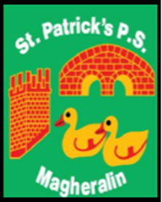

ST. PATRICK’S PRIMARY SCHOOL
12 Ballymacbredan Road, Magheralin, Craigavon. BT67 OQU
Tel no – 028 3834 1400 Fax no – 028 3834 7376
Email: info@stpatricks.magheralin.ni.sch.uk
Principal: Mrs. M. McGrath. BA(QTS), PQHSH, DipPD.
‘Together we learn, together we grow, developing our future, wherever we go!’

14th June 2021

Dear Parent/Guardian

Last week our Gardening Club were very disappointed and disheartened to find that the school greenhouse had been entered and their pumpkin seed pots had been upturned and therefore destroyed.

Our children and their assistants have been really enjoying and working very hard in their gardening club all year and this has obviously caused upset.

Could we ask that all parents/carers are vigilant whilst on the school grounds and that if you notice anything untoward during drop off and collection times, evenings or weekends that you contact the school office.

We appreciate your support in this matter.

Kind Regards
Mrs M McGrath
Principal

