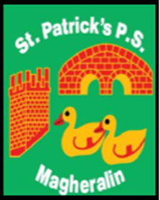

ST. PATRICK’S PRIMARY SCHOOL
12 Ballymacbredan Road, Magheralin, Craigavon. BT67 OQU
Tel no – 028 3834 1400 Fax no – 028 3834 7376
Email: info@stpatricks.magheralin.ni.sch.uk
Principal: Mrs. M. McGrath. BA(QTS), PQHSH, DipPD.
‘Together we learn, together we grow, developing our future, wherever we go!’

16th September 2022

Dear Parent/Guardian

Below you will see a table of afterschool clubs available this term.
Please use the Eduspot System to book your child into our clubs.
Please note that Healthy Kidz and Evo Soccer are booked via these providers, directly.
A further club, ‘Minds in Motion’, will be available after the Halloween break, for a period of 6 weeks, to children in classes P1 to P3 each Wednesday, 2-3pm. Further information will be circulated closer to the time.

 | Mon | Tues | Wed | Thurs | Fri
2:00 – 3:00 | Homework Club | Lego | Lego | Homework Club | Garden Club
3:00 – 4:00 | Crafts/Art  P7 Transfer club  Evo Soccer | Outside games  P7 Transfer club  Healthy Kidz | Netball Club | Lego  Running Club  Healthy Kidz | N/A
4:00 – 5:00 | Homework Club | Homework Club | Homework Club | Homework Club | N/A

