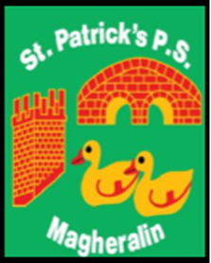

ST. PATRICK’S PRIMARY SCHOOL
12 Ballymacbredan Road, Magheralin, Craigavon. BT67 OQU
Tel no – 028 3834 1400 Fax no – 028 3834 7376
Email: info@stpatricks.magheralin.ni.sch.uk
Principal: Mrs. M. McGrath. BA(QTS), PQHSH, DipPD.
‘Together we learn, together we grow, developing our future, wherever we go!’

8th February 2023

Dear Parents

Please read the following information re school closures.

Mid-Term: The school will be closed for the mid-term holidays from Monday 13th – Friday 17th February inclusive.

Union Action: NASUWT, INTO and UTU Teaching Unions have stated their intention to call on their members to participate in strike action on Tuesday 21st February 2023. These trade Unions have confirmed that the action will take place from 12 midnight to 12 noon on this date.
Teaching staff will be unavailable for work until 12 noon on Tuesday 21st February. From 12 noon teaching staff will resume their teaching duties. Therefore school will be closed for students on Tuesday 21st February until 12 noon.

School dinners: If you wish your child to have school dinners on Tuesday 21st February, we ask that all dinners are booked for that day, by Monday 20th February, using the online booking system.

Yours sincerely,
Mrs M McGrath Principal

