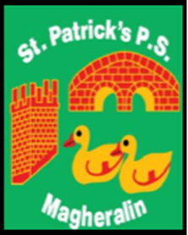

ST. PATRICK’S PRIMARY SCHOOL
12 Ballymacbredan Road, Magheralin, Craigavon. BT67 OQU
Tel no – 028 3834 1400 Fax no – 028 3834 7376
Email: info@stpatricks.magheralin.ni.sch.uk
Principal: Mrs. M. McGrath. BA(QTS), PQHSH, PGDip.
‘Together we learn, together we grow, developing our future, wherever we go!’

22nd February 2023

Dear Parent/Guardian

Lurgan Credit Union Limited are introducing a NEW Savings Incentive Scheme.

For every £1000 saved by the pupils of our school through the Credit Union school savers scheme, Lurgan Credit Union will donate £100 to our school, up to a maximum donation of £300 per school year.

The purpose of the Schools Savings Scheme is to encourage children to start saving on a regular basis from an early age. The savings scheme operates on a monthly basis. A Credit Union account will be opened for each pupil interested, which will record all lodgements made by the pupils. If the pupil already has an account with the Credit Union, they can use this account to save through the school.

If you wish your child to join the school savings scheme please contact the school office for an application form.

M. McGrath
Principal

