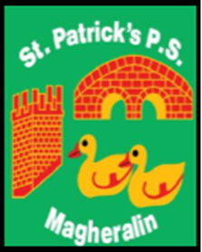

ST. PATRICK’S PRIMARY SCHOOL
12 Ballymacbredan Road, Magheralin, Craigavon. BT67 OQU
Tel no – 028 3834 1400 Fax no – 028 3834 7376
Email: info@stpatricks.magheralin.ni.sch.uk
Principal: Mrs. M. McGrath. BA(QTS), PQHSH, DipPD.
‘Together we learn, together we grow, developing our future, wherever we go!’

5th May 2023

Dear Parent/Guardian

I write to inform you that this year we are to acknowledge the official retirement of, Mrs Anne Mellors, from our school.

Anne began working in St Patrick’s Primary School on 21st September 1992, and has given just over 30 years of support, care and attention to many children and families of this community. She has also been a valued and supportive colleague to many members of teaching and non-teaching staff throughout her time in St Patrick’s.

We will celebrate Anne’s service to our school community on Friday 2nd June, as the children will present an assembly in her honour.

If you would like to contribute to a parental gift, that would be presented to Anne on this day by the children, you may do so now via Eduspot. This is listed as Anne Mellors Retirement gift and there are 3 different donation options.

May I take this opportunity to thank Anne for her service to this school and friendship to her colleagues. We all wish her good luck and God’s richest blessings in her retirement.

Yours sincerely
Mrs McGrath
Principal

