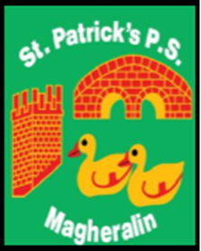

ST. PATRICK’S PRIMARY SCHOOL
12 Ballymacbredan Road, Magheralin, Craigavon. BT67 OQU
Tel no – 028 3834 1400 Fax no – 028 3834 7376
Email: info@stpatricks.magheralin.ni.sch.uk
Principal: Mrs. M. McGrath. BA(QTS), PQHSH, DipPD.
‘Together we learn, together we grow, developing our future, wherever we go!’

May 2023

Dear Parent / Guardian

St. Patrick’s Primary School will be holding their annual Sports Day on Tuesday, 23rd May 2023, from 10.00am to 12.00 noon, weather permitting.

Our sports day will be located at St. Michael’s Gaelic pitch. Parents will enter the field via the school grounds. School gates will be locked as normal, please do not park in front of the school gates.

Sports day will be organised into six stations; each class will be assigned to a particular station. Classes will rotate around all six stations throughout the day. Parents may spectate at any of the stations but must not enter the station area. Children must remain with their teachers and assistants.

Refreshments will be provided for spectators. On the day, donations towards the purchase of school equipment would be greatly appreciated and this may be done at the coffee dock area.

Pupils are not permitted to leave their class teacher at any time. Tesco will provide the pupils with a healthy snack.
Each pupil must bring their own water bottle and hat. Please apply sun cream to your child before coming to school.

Many thanks for your co-operation,

Mrs Gail Magennis

