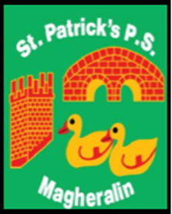

ST. PATRICK’S PRIMARY SCHOOL
12 Ballymacbredan Road, Magheralin, Craigavon. BT67 OQU
Tel no – 028 3834 1400 Fax no – 028 3834 7376
Email: info@stpatricks.magheralin.ni.sch.uk
Principal: Mrs. M. McGrath. BA(QTS), PQHSH, DipPD.
‘Together we learn, together we grow, developing our future, wherever we go!’

4th July 2023

Dear Parent/Guardian

I hope that you and your families will be able to enjoy some relaxing time together over this summer period and hopefully a warm spell of weather will return for you all to enjoy.

I would like to confirm, that subject to ratification, Miss Amy Bannon will be joining the team in St. Patrick’s, as she will be teaching in our Primary 2 class from September 2023. Miss Bannon is looking forward to working with the children.

I take this opportunity to welcome Miss Bannon to the team and pray that she has many happy years working in St Patrick’s Primary School.

Yours sincerely

Mrs M. McGrath
Principal

