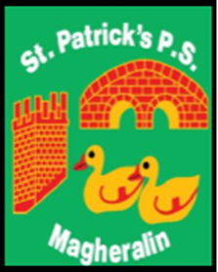

ST. PATRICK’S PRIMARY SCHOOL
12 Ballymacbredan Road, Magheralin, Craigavon. BT67 OQU
Tel no – 028 3834 1400 Fax no – 028 3834 7376
Email: info@stpatricks.magheralin.ni.sch.uk
Principal: Mrs. M. McGrath. BA(QTS), PQHSH, DipPD.
‘Together we learn, together we grow, developing our future, wherever we go!’

22nd November 2023

Dear Parent/ Guardian

Union Action: NASUWT, INTO and UTU, NEU and NAHT Teaching Unions have stated their intention to call on their members to participate in strike action on Wednesday 29th November 2023. These trade Unions have confirmed that the action will take place from 12 midnight to 12 noon on this date.
Teaching staff will be unavailable for work until 12 noon on Wednesday 29th November. From 12 noon, teaching staff will resume their teaching duties.
Therefore, school will be closed for students on Wednesday 29th November until 12 noon.
Breakfast and Drop Off Club will be unavailable on this morning.
School dinners: If you wish your child to have school dinners on Wednesday 29th November, we ask that all dinners are booked for that day, by Monday 27th November, using the online booking system.
Afterschool Clubs: Clubs will run as normal on Wednesday afternoon.

Yours sincerely,
Mrs M McGrath Principal

