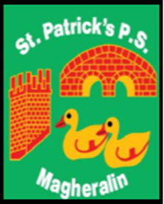

**ST. PATRICK’S PRIMARY SCHOOL**

**12 Ballymacbredan Road, Magheralin, Craigavon. BT67 OQU**

**Tel no – 028 3834 1400 Fax no – 028 3834 7376**

**Email: info@stpatricks.magheralin.ni.sch.uk**

**Principal: Mrs. M. McGrath. BA(QTS), PQHSH, DipPD.**

**‘Together we learn, together we grow, developing our future, wherever we go!’**

12th March 2024

Dear Parent



Primary 7 children would like to thank all those who have returned their filled smartie tubes to date and remind everyone that we would love to have them all returned to school before Easter.

We will also have an Easter Egg raffle in school! Tickets can be bought on Eduspot at £1 for 2 tickets and £2 for 5 tickets. The raffle will take place on Wednesday 27th March.

The proceeds of the raffle will also go towards our Primary 7 children who are fundraising for playground equipment. 

This Friday in school, we will celebrate St Patrick’s Day, with Green Day in school. Your child may come to school in their own clothes of green colours to celebrate our national Saint. If any of our children would like to bring in their Irish dancing costumes and music, we would love them to dance and celebrate with us!



Thank you in advance of your support!

Mrs M McGrath