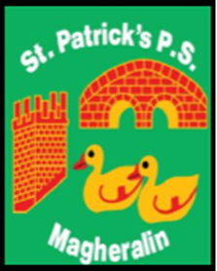

**ST. PATRICK’S PRIMARY SCHOOL**

**12 Ballymacbredan Road, Magheralin, Craigavon. BT67 OQU**

**Tel no – 028 3834 1400 Fax no – 028 3834 7376**

**Email: info@stpatricks.magheralin.ni.sch.uk**

**Principal: Mrs. M. McGrath. BA(QTS), PQHSH, DipPD.**

**‘Together we learn, together we grow, developing our future, wherever we go!’**

22nd March 2024

Dear Parent / Guardian

As we approach the better evenings and as our children get a little older and more confident throughout their school year, we can see that they are being encouraged to walk to the school carpark or to the school gate at home time for their pickup.

It is with this in mind that I reach out to our school community at this time and ask for extra consideration as drivers, when entering, exiting and driving within the school grounds.

Our one-way system aims to ease the movement of traffic and further support the safety of our children at school. I ask that your speed is restricted to 5MPH as you enter and exit the school grounds and that drop off bays are used for quick drop off and pickups only. Please take extra care as you approach the pedestrian crossing on the driveway.

The safety of our children is our paramount concern.

I thank you in advance of your continued support.

Kind Regards

Mrs M McGrath