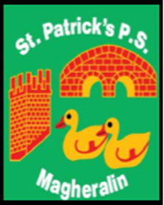

ST. PATRICK’S PRIMARY SCHOOL
12 Ballymacbredan Road, Magheralin, Craigavon. BT67 OQU
Tel no – 028 3834 1400 Fax no – 028 3834 7376
Email: info@stpatricks.magheralin.ni.sch.uk
Principal: Mrs. M. McGrath. BA(QTS), PQHSH, DipPD.
‘Together we learn, together we grow, developing our future, wherever we go!’

11th January 2019

Dear Parent

Upgrade to our heating system
Following on from the letter we posted on our website before Christmas, we have recently been informed by the Education Authority that our school has qualified for an upgrade to our current heating system. We are delighted that this work has been approved and will commence during January.
You may have already seen some preparation starting with the delivery of our new oil tank. We will be receiving deliveries and more equipment during the next few weeks and whenever possible we have arranged these outside drop off and collection times.
In exceptional circumstances, deliveries may take place during drop off and collection times. We kindly ask for your patience with delivery lorries and that you use allocated parking spaces within the car park whenever possible. Please also share this information with anyone who is involved in your child’s care.
The majority of the work will centre around the current boiler house and the shelter, at the front of the school. We will need to make some changes as to how children are picked up and leave the school building and will update you when the work starts.
We appreciate your support during these essential works and thank you for your patience.
Yours sincerely

Mrs. M McGrath
Principal

