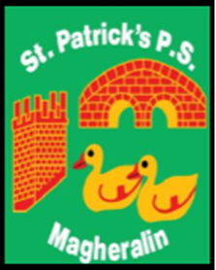

ST. PATRICK’S PRIMARY SCHOOL
12 Ballymacbredan Road, Magheralin, Craigavon. BT67 OQU
Tel no – 028 3834 1400 Fax no – 028 3834 7376
Email: info@stpatricks.magheralin.ni.sch.uk
Principal: Mrs. M. McGrath. BA(QTS), PQHSH, DipPD.
‘Together we learn, together we grow, developing our future, wherever we go!’

January 2019

Dear Parent,

As you are aware all schools are continuing to suffer the effects of school budget reductions. We, as a Board of Governors and school staff, have been absorbing these cuts in our school for a number of years, to the best of our ability.
All schools are facing very tough economic times ahead and are now, or already have been, requesting support from parents. We aim to always keep this to a minimum.
We respectfully ask that our parents make voluntary contributions to our School Fund, of £5 per child per term, to a maximum of £10 per family per term.
This money will be spent on termly requirements, which will be used to enhance your child’s learning environment and help purchase school resources.

This payment can be made using our online service.

Yours sincerely,

Mrs. McGrath
Principal
On behalf of the Board of Governors

