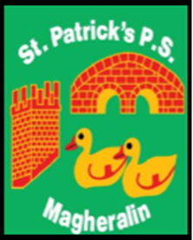

ST. PATRICK’S PRIMARY SCHOOL
12 Ballymacbredan Road, Magheralin, Craigavon. BT67 OQU
Tel no – 028 3834 1400 Fax no – 028 3834 7376
Email: info@stpatricks.magheralin.ni.sch.uk
Principal: Mrs. M. McGrath. BA(QTS), PQHSH, DipPD.
‘Together we learn, together we grow, developing our future, wherever we go!’

27th February 2019

Dear Parent
World Book Day 2019
World Book Day takes place next week on Thursday 7th March.
As part of our celebrations this year, we are taking our Reception to Primary 4 classes to ‘Milo’s Hat Trick’, written by Jon Agee, being staged at Armagh’s Market Place Theatre. This is a perfect introduction to theatre and the enjoyment of novels for young children.
Last year’s photograph competition was very successful and this year we are asking all children to bring in a photograph of themselves sharing their favourite book with friends or family in an unusual place. The aim is to encourage children to explore the pleasure of books all around them and to share their joy of reading no matter where they may be.
The photographs can be sent in any day before Thursday 7th March to the class teacher.
Once again, we are asking all families to hunt out any unwanted books in a reasonable condition and our Primary 7 class will have a book sale on Friday 8th March. Boxes will be available in the foyer from tomorrow to drop off all unwanted books, so we can sort these out. All money raised will go towards Literacy resources within the school.
We look forward to seeing all the wonderful entries which will be displayed in our school entrance hall for everyone to see.
Yours sincerely

Miss K Oliver
Literacy Co-Ordinator 