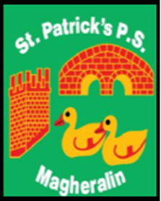

ST. PATRICK’S PRIMARY SCHOOL
12 Ballymacbredan Road, Magheralin, Craigavon. BT67 OQU
Tel no – 028 3834 1400 Fax no – 028 3834 7376
Email: info@stpatricks.magheralin.ni.sch.uk
Principal: Mrs. M. McGrath. BA(QTS), PQHSH, DipPD.
‘Together we learn, together we grow, developing our future, wherever we go!’

17th May 2019

Dear Parent
Your ongoing support
We had a very special and busy week in St Patrick’s celebrating two important Sacraments in our school life, Holy Communion and Confirmation.
I am very proud of all the hard work and preparation from our children and staff for both Sacraments.
I wish to extend sincere thanks to the parents who supported the events in the hall this week, whether it was collecting cakes, setting up, organising flowers or serving tea. Your support is invaluable.
A special word of thanks to Maureen McCann, who co-ordinated volunteers and helped host both events.
We always work hard with all involved in the Parish to ensure we can give the earliest possible notice when asking for help, as we understand family and work commitments. We have 91 families within our school community so each family’s support is very important.
Our plan for September is to outline as many key dates (even if these are provisional) as possible on our website, with reminders of these at the start of each term to allow you to see what’s in store each month.
Thank you for your ongoing support.
Yours sincerely

Mrs M. McGrath
Principal

