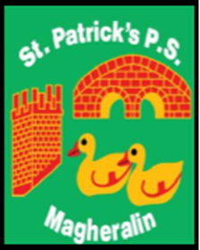

ST. PATRICK’S PRIMARY SCHOOL
12 Ballymacbredan Road, Magheralin, Craigavon. BT67 OQU
Tel no – 028 3834 1400 Fax no – 028 3834 7376
Email: info@stpatricks.magheralin.ni.sch.uk
Principal: Mrs. M. McGrath. BA(QTS), PQHSH, DipPD.
‘Together we learn, together we grow, developing our future, wherever we go!’

September 2019

Dear Parents

Mrs Jan Hutchinson, SELB Music Service, shall be in school each Wednesday to teach the violin and choir to our children from Primary 5, Primary 6 and Primary 7. This is a very valuable part of our music curriculum and we are very lucky to have this service in our school. The lessons will begin on Wednesday 11th September.

The cost of tuition is £1:00 per week.

Furthermore, we are delighted to have again accessed the Down GAA Coaching Programme in our school for children in Key Stage 2 (Primary 5, 6 and 7). Schools accessing this valuable programme are charged for this support. We do not have a start date as yet from Down GAA. We will inform you as soon as it is made known to us.

The cost of this programme is 70p per week.

You can pay these amounts using our online service.
Thank you in advance for your support.

Mrs McGrath

PRINCIPAL

