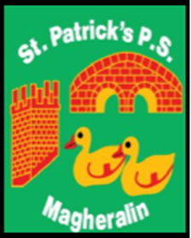

ST. PATRICK’S PRIMARY SCHOOL
12 Ballymacbredan Road, Magheralin, Craigavon. BT67 OQU
Tel no – 028 3834 1400 Fax no – 028 3834 7376
Email: info@stpatricks.magheralin.ni.sch.uk
Principal: Mrs. M. McGrath. BA(QTS), PQHSH, DipPD.
‘Together we learn, together we grow, developing our future, wherever we go!’

September 2019

Dear Parent,

As you are aware all schools are continuing to suffer the effects of school budget reductions. We, as a Board of Governors and school staff, have been absorbing these cuts in our school for a number of years, to the best of our ability.
Due to these continued cuts to school budgets, we respectfully ask that our parents make a voluntary contribution to our School Fund, of £5 per child per term, to a maximum of £10 per family per term.
This money will be spent on termly requirements, which will be used to enhance your child’s learning environment and help purchase school resources.
This year we will continue with our texting service and online money service to parents. To support us in the cost of this very valuable and convenient service, we ask each family to contribute the sum of £15:00. This payment can be made using our online service. It can be made as £5 per term or as one payment.

A text has been sent to all parents today. Can you please inform the office if you did not receive a text, as this will ensure that all of our contact details are correct.

All schools are facing very tough economic times ahead and are now, or already have been, requesting support from parents. We aim to always keep this to a minimum.

These payments can be made using our online service.

Yours sincerely,

Mrs. McGrath
Principal
On behalf of the Board of Governors

