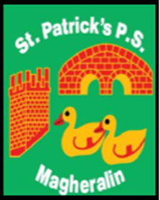

ST. PATRICK’S PRIMARY SCHOOL
12 Ballymacbredan Road, Magheralin, Craigavon. BT67 OQU
Tel no – 028 3834 1400 Fax no – 028 3834 7376
Email: info@stpatricks.magheralin.ni.sch.uk
Principal: Mrs. M. McGrath. BA(QTS), PQHSH, DipPD.
‘Together we learn, together we grow, developing our future, wherever we go!’

9th December 2019

Dear Parent,

Our performance of ‘I’m Gonna Shine’ will take place on Tuesday 17th December at 10:00am and Wednesday 18th December at 7:00pm, in the Parish Hall, Magheralin.

Tickets are now on sale at £3:00 each. Please note that we will be allocating 2 tickets to each family. If you do not receive your first choice of performance, please state if you would like to receive tickets for the second performance on offer.

If you wish to purchase tickets, please state which performance the tickets are for and enclose the correct amount into a sealed, clearly labelled envelope for the attention of the school office. Please let the office know if you wish to purchase tickets by Friday 13th December.

Any additional tickets will go on sale after each family has been given an opportunity to purchase tickets, on Monday 16th December.

Please note that seats in the hall are not numbered so you take your seat on arrival.

A DVD will be on sale after the event!

Yours sincerely,
Mrs M. McGrath

