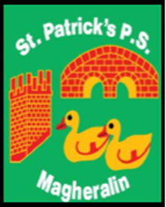

ST. PATRICK’S PRIMARY SCHOOL
12 Ballymacbredan Road, Magheralin, Craigavon. BT67 OQU
Tel no – 028 3834 1400 Fax no – 028 3834 7376
Email: info@stpatricks.magheralin.ni.sch.uk
Principal: Mrs. M. McGrath. BA(QTS), PQHSH, DipPD.
‘Together we learn, together we grow, developing our future, wherever we go!’

16th March 2020

Dear Parents

I write to keep you informed of our current status in relation to school openings and future closure.
The advice from the Department of Education, as of this afternoon, is that schools will continue to remain open at this point. Education Minister, Peter Weir, has stated:
"The position on COVID-19 is exceptionally fast moving and new developments are emerging on a daily basis.’

We are aware that schools will be instructed to close at some stage and that this may be for a prolonged period.

Considering parental concerns in relation to Coronavirus, it is understandable if parents wish to keep their children at home, in particular if your child, or anyone in the home, has an underlying illness. In these specific circumstances, we have been advised that we can record pupil absence as an authorised absence.

I am currently liaising with our website provider to see how we can provide work for pupils in the event of a prolonged absence from school. All available options will be explored.
School will, at this point, re-open as planned on Wednesday 18th March.

I will keep you informed of any developments as soon as they arrive.
We at St Patrick’s aim, as always, to work in partnership with you and our entire school community.

Yours sincerely,
Mrs M. McGrath

