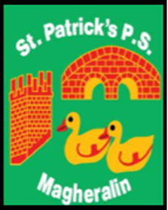

ST. PATRICK’S PRIMARY SCHOOL
12 Ballymacbredan Road, Magheralin, Craigavon. BT67 OQU
Tel no – 028 3834 1400 Fax no – 028 3834 7376
Email: info@stpatricks.magheralin.ni.sch.uk
Principal: Mrs. M. McGrath. BA(QTS), PQHSH, DipPD.
‘Together we learn, together we grow, developing our future, wherever we go!’

20th March 2020

Dear Parents

The Minister for Education outlined how schools will support some key workers in light of the current situation around Coronavirus, from Monday 23rd March.

We aim to help parents who are critical in the fight against Covid-19. In order to support them it is imperative that we are aware of how many children of key workers will be attending school on Monday morning.

Can you please check with your employer to ascertain if you are on the key worker list.

If you are an identified key worker, please contact us at school by 3:30pm today, Friday 20th March, via phone or email as listed above.

We aim to support, bearing in mind our staffing levels may change over time, as this situation impacts all of our lives.

Please note this is aimed directly at children of parents who are key workers.

If possible, alternative childcare arrangements should be sought before deciding to send your child/ren to school, in order to limit the number of children and adults together in a small space. This is in line with recent social distancing guidance.

We ask parents to think carefully before deciding to send your child/ren to school.

The school day will run from 9am to 3pm ONLY.

You must contact us at school immediately if you are a key worker who urgently needs this service and we will endeavour to support you in your important role.

Kind Regards

Mrs M. McGrath

